**Lab program-1a.** Create an application to design a Visiting Card. The Visiting card should have a company logo at the top right corner. The company name should be displayed in Capital letters, aligned to the center. Information like the name of the employee, job title, phone number, address, email, fax and the website address is to be displayed. Insert a horizontal line between the job title and the phone number.

activity_main.xml

<LinearLayout xmlns:android=*"http://schemas.android.com/apk/res/android"*

xmlns:tools=*"http://schemas.android.com/tools"*

android:layout_width=*"match_parent"*

android:layout_height=*"match_parent"*

android:paddingBottom=*"@dimen/activity_vertical_margin"*

android:paddingLeft=*"@dimen/activity_horizontal_margin"*

android:paddingRight=*"@dimen/activity_horizontal_margin"*

android:paddingTop=*"@dimen/activity_vertical_margin"*

android:orientation=*"vertical"*

android:gravity=*"center"*

tools:context=*".MainActivity"* >

<LinearLayout

android:layout_width=*"wrap_content"*

android:layout_height=*"wrap_content"*

android:layout_gravity=*"center_horizontal"*>

<TextView

android:layout_width=*"wrap_content"*

android:layout_height=*"wrap_content"*

android:gravity=*"center_horizontal"*

android:layout_gravity=*"center"*

android:text=*"DR.AIT"*

android:textSize=*"30sp"* />

<ImageView

android:layout_width=*"40dp"*

android:layout_height=*"40dp"*

android:src=*"@drawable/college_logo"*/>

</LinearLayout>

<View

android:layout_width=*"fill_parent"*

android:layout_height=*"1dp"*

android:background=*"#000000"*/>

<LinearLayout

android:layout_width=*"wrap_content"*

android:layout_height=*"wrap_content"*

android:gravity=*"center_vertical"*

android:orientation=*"vertical"*>

<TextView

android:layout_width=*"wrap_content"*

android:layout_height=*"wrap_content"*

android:layout_gravity=*"center"*

android:text=*"Name:Rakshith S"*

android:textSize=*"20sp"*

android:layout_marginTop=*"20dp"* />

<TextView

android:layout_width=*"wrap_content"*

android:layout_height=*"wrap_content"*

android:layout_gravity=*"center"*

android:text=*"Email:1da20cs112.cs@drait.edu.in"*

android:layout_marginTop=*"10dp"*

android:textSize=*"18sp"*/>

<TextView

android:layout_width=*"wrap_content"*

android:layout_height=*"wrap_content"*

android:layout_gravity=*"center"*

android:layout_marginTop=*"10dp"*

android:text=*"Address:Bengaluru,Karnataka"*

android:textSize=*"18sp"*/>

<TextView

android:layout_width=*"wrap_content"*

android:layout_height=*"wrap_content"*

android:layout_gravity=*"center"*

android:layout_marginTop=*"10dp"*

android:text=*"Phone No.1234056789"*

android:textSize=*"18sp"*/>

</LinearLayout>

</LinearLayout>

MainActivity.java

**package** com.example.visitingcard;

**import** android.os.Bundle;

**import** android.app.Activity;

**import** android.view.Menu;

**public** **class** MainActivity **extends** Activity {

@Override

**protected** **void** onCreate(Bundle savedInstanceState) {

**super**.onCreate(savedInstanceState);

setContentView(R.layout.*activity_main*);

}

@Override

**public** **boolean** onCreateOptionsMenu(Menu menu) {

// Inflate the menu; this adds items to the action bar if it is present.

getMenuInflater().inflate(R.menu.*main*, menu);

**return** **true**;

}

}

**Lab program-9.** Create an activity like a phone dialer with (1,2,3,4,5,6,7,8,9,0,*,#) buttons and call and save button on pressing the call button, it must call the phone number and on pressing the save button it must save the number to the phone contacts**.**

activity_main.xml

<LinearLayout xmlns:android=*"http://schemas.android.com/apk/res/android"*

xmlns:tools=*"http://schemas.android.com/tools"*

android:layout_width=*"match_parent"*

android:layout_height=*"match_parent"*

android:paddingBottom=*"@dimen/activity_vertical_margin"*

android:paddingLeft=*"@dimen/activity_horizontal_margin"*

android:paddingRight=*"@dimen/activity_horizontal_margin"*

android:paddingTop=*"@dimen/activity_vertical_margin"*

android:orientation=*"vertical"*

tools:context=*".MainActivity"* >

<EditText

android:layout_width=*"match_parent"*

android:layout_height=*"wrap_content"*

android:layout_marginTop=*"20dp"*

android:id=*"@+id/txt_num"*/>

<LinearLayout

android:layout_width=*"match_parent"*

android:layout_height=*"wrap_content"*

android:layout_gravity=*"center_horizontal"*

android:layout_marginTop=*"20dp"*

android:gravity=*"center"*>

<Button

android:layout_width=*"wrap_content"*

android:layout_height=*"wrap_content"*

android:layout_gravity=*"center_horizontal"*

android:text=*"1"*

android:layout_marginTop=*"20dp"*

android:id=*"@+id/btn_one"* />

<Button

android:layout_width=*"wrap_content"*

android:layout_height=*"wrap_content"*

android:layout_marginTop=*"20dp"*

android:text=*"2"*

android:id=*"@+id/btn_two"*

android:layout_gravity=*"center_horizontal"*/>

<Button

android:layout_width=*"wrap_content"*

android:layout_height=*"wrap_content"*

android:layout_marginTop=*"20dp"*

android:text=*"3"*

android:id=*"@+id/btn_three"*

android:layout_gravity=*"center_horizontal"*/>

</LinearLayout>

<LinearLayout

android:layout_width=*"match_parent"*

android:layout_height=*"wrap_content"*

android:layout_gravity=*"center_horizontal"*

android:gravity=*"center"*>

<Button

android:layout_width=*"wrap_content"*

android:layout_height=*"wrap_content"*

android:layout_gravity=*"center_horizontal"*

android:text=*"4"*

android:layout_marginTop=*"20dp"*

android:id=*"@+id/btn_four"* />

<Button

android:layout_width=*"wrap_content"*

android:layout_height=*"wrap_content"*

android:layout_marginTop=*"20dp"*

android:text=*"5"*

android:id=*"@+id/btn_five"*

android:layout_gravity=*"center_horizontal"*/>

<Button

android:layout_width=*"wrap_content"*

android:layout_height=*"wrap_content"*

android:layout_marginTop=*"20dp"*

android:text=*"6"*

android:id=*"@+id/btn_six"*

android:layout_gravity=*"center_horizontal"*/>

</LinearLayout>

<LinearLayout

android:layout_width=*"match_parent"*

android:layout_height=*"wrap_content"*

android:layout_gravity=*"center_horizontal"*

android:gravity=*"center"*>

<Button

android:layout_width=*"wrap_content"*

android:layout_height=*"wrap_content"*

android:layout_gravity=*"center_horizontal"*

android:text=*"7"*

android:layout_marginTop=*"20dp"*

android:id=*"@+id/btn_seven"* />

<Button

android:layout_width=*"wrap_content"*

android:layout_height=*"wrap_content"*

android:layout_marginTop=*"20dp"*

android:text=*"8"*

android:id=*"@+id/btn_eight"*

android:layout_gravity=*"center_horizontal"*/>

<Button

android:layout_width=*"wrap_content"*

android:layout_height=*"wrap_content"*

android:layout_marginTop=*"20dp"*

android:text=*"9"*

android:id=*"@+id/btn_nine"*

android:layout_gravity=*"center_horizontal"*/>

</LinearLayout>

<LinearLayout

android:layout_width=*"match_parent"*

android:layout_height=*"wrap_content"*

android:layout_gravity=*"center_horizontal"*

android:gravity=*"center"*>

<Button

android:layout_width=*"wrap_content"*

android:layout_height=*"wrap_content"*

android:layout_gravity=*"center_horizontal"*

android:text=*"*"*

android:layout_marginTop=*"20dp"*

android:id=*"@+id/btn_star"* />

<Button

android:layout_width=*"wrap_content"*

android:layout_height=*"wrap_content"*

android:layout_marginTop=*"20dp"*

android:text=*"0"*

android:id=*"@+id/btn_zero"*

android:layout_gravity=*"center_horizontal"*/>

<Button

android:layout_width=*"wrap_content"*

android:layout_height=*"wrap_content"*

android:layout_marginTop=*"20dp"*

android:text=*"#"*

android:id=*"@+id/btn_hash"*

android:layout_gravity=*"center_horizontal"*/>

</LinearLayout>

<LinearLayout

android:layout_width=*"match_parent"*

android:layout_height=*"wrap_content"*

android:layout_gravity=*"center_horizontal"*

android:gravity=*"center"*>

<Button

android:layout_width=*"wrap_content"*

android:layout_height=*"wrap_content"*

android:layout_gravity=*"center_horizontal"*

android:text=*"SAVE"*

android:layout_marginTop=*"20dp"*

android:id=*"@+id/btn_save"* />

<Button

android:layout_width=*"wrap_content"*

android:layout_height=*"wrap_content"*

android:layout_marginTop=*"20dp"*

android:text=*"CALL"*

android:id=*"@+id/btn_call"*

android:layout_gravity=*"center_horizontal"*/>

<Button

android:layout_width=*"wrap_content"*

android:layout_height=*"wrap_content"*

android:layout_marginTop=*"20dp"*

android:text=*"DELETE"*

android:id=*"@+id/btn_delete"*

android:layout_gravity=*"center_horizontal"*/>

</LinearLayout>

</LinearLayout>

MainActivity.java

**package** com.example.dialpad;

**import** android.net.Uri;

**import** android.os.Bundle;

**import** android.provider.ContactsContract;

**import** android.app.Activity;

**import** android.content.Intent;

**import** android.view.Menu;

**import** android.view.View;

**import** android.view.View.OnClickListener;

**import** android.widget.Button;

**import** android.widget.EditText;

**public** **class** MainActivity **extends** Activity **implements** OnClickListener {

Button one,two,three,four,five,six,seven,eight,nine,zero,star,hash,save,call,delete;

EditText number;

@Override

**protected** **void** onCreate(Bundle savedInstanceState) {

**super**.onCreate(savedInstanceState);

setContentView(R.layout.*activity_main*);

number=(EditText)findViewById(R.id.*txt_num*);

one=(Button)findViewById(R.id.*btn_one*);

one.setOnClickListener(**this**);

two=(Button)findViewById(R.id.*btn_two*);

two.setOnClickListener(**this**);

three=(Button)findViewById(R.id.*btn_three*);

three.setOnClickListener(**this**);

four=(Button)findViewById(R.id.*btn_four*);

four.setOnClickListener(**this**);

five=(Button)findViewById(R.id.*btn_five*);

five.setOnClickListener(**this**);

six=(Button)findViewById(R.id.*btn_six*);

six.setOnClickListener(**this**);

seven=(Button)findViewById(R.id.*btn_seven*);

seven.setOnClickListener(**this**);

eight=(Button)findViewById(R.id.*btn_eight*);

eight.setOnClickListener(**this**);

nine=(Button)findViewById(R.id.*btn_nine*);

nine.setOnClickListener(**this**);

zero=(Button)findViewById(R.id.*btn_zero*);

zero.setOnClickListener(**this**);

star=(Button)findViewById(R.id.*btn_star*);

star.setOnClickListener(**this**);

hash=(Button)findViewById(R.id.*btn_hash*);

hash.setOnClickListener(**this**);

call=(Button)findViewById(R.id.*btn_call*);

call.setOnClickListener(**this**);

save=(Button)findViewById(R.id.*btn_save*);

save.setOnClickListener(**this**);

delete=(Button)findViewById(R.id.*btn_delete*);

delete.setOnClickListener(**this**);

}

@Override

**public** **boolean** onCreateOptionsMenu(Menu menu) {

// Inflate the menu; this adds items to the action bar if it is present.

getMenuInflater().inflate(R.menu.*main*, menu);

**return** **true**;

}

@Override

**public** **void** onClick(View v) {

// **TODO** Auto-generated method stub

**if**(v.equals(one)){

number.append("1");

}

**else** **if**(v.equals(two)){

number.append("2");

}

**else** **if**(v.equals(three)){

number.append("3");

}

**else** **if**(v.equals(four)){

number.append("4");

}

**else** **if**(v.equals(five)){

number.append("5");

}

**else** **if**(v.equals(six)){

number.append("6");

}

**else** **if**(v.equals(seven)){

number.append("7");

}

**else** **if**(v.equals(eight)){

number.append("8");

}

**else** **if**(v.equals(nine)){

number.append("9");

}

**else** **if**(v.equals(zero)){

number.append("0");

}

**else** **if**(v.equals(star)){

number.append("*");

}

**else** **if**(v.equals(hash)){

number.append("#");

}

**else** **if**(v.equals(delete)){

String phone=number.getText().toString();

**if**(phone.length()>0){

phone=phone.substring(0,phone.length()-1);

}

number.setText(phone);

}

**else** **if**(v.equals(call)){

String phone=number.getText().toString();

Intent it=**new** Intent(Intent.*ACTION_CALL*);

it.setData(Uri.*parse*("tel:"+phone));

startActivity(it);

}

**else** **if**(v.equals(save)){

String phone=number.getText().toString();

Intent intent=**new** Intent(Intent.*ACTION_INSERT*,ContactsContract.Contacts.*CONTENT_URI*);

intent.putExtra(ContactsContract.Intents.Insert.*PHONE*, phone);

startActivity(intent);

}

}

}

Dial Pad Manifest (AndroidManifest.xml)

<uses-permission

android:name=*"android.permission.CALL_PHONE"*/>

(Note: A picture has been attached below which shows the place to include the above snippet)

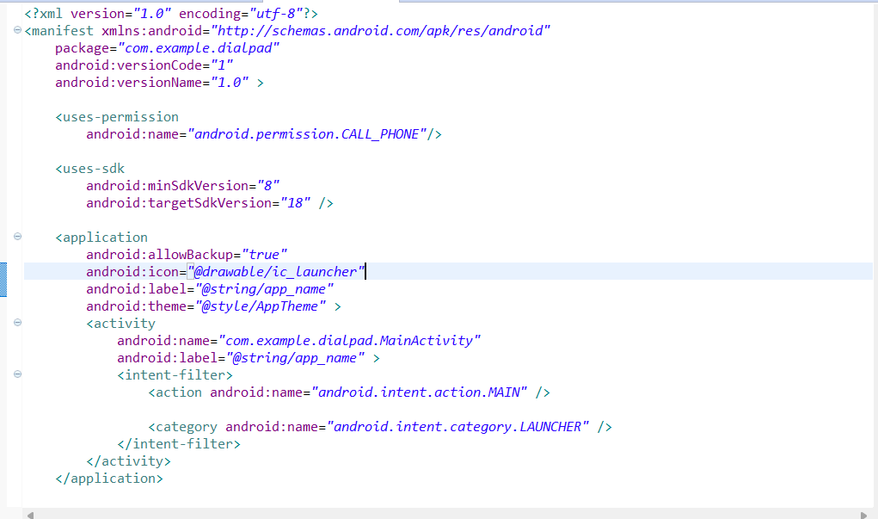

**Lab program-5.** Create a program to create an activity with two buttons start and stop. On pressing start button the program must start the counter and must keep on counting until stop button is pressed.

activity_main.xml

<LinearLayout xmlns:android=*"http://schemas.android.com/apk/res/android"*

xmlns:tools=*"http://schemas.android.com/tools"*

android:layout_width=*"match_parent"*

android:layout_height=*"match_parent"*

android:paddingBottom=*"@dimen/activity_vertical_margin"*

android:paddingLeft=*"@dimen/activity_horizontal_margin"*

android:paddingRight=*"@dimen/activity_horizontal_margin"*

android:paddingTop=*"@dimen/activity_vertical_margin"*

android:orientation=*"vertical"*

tools:context=*".MainActivity"* >

<Button

android:layout_width=*"wrap_content"*

android:layout_height=*"wrap_content"*

android:id=*"@+id/btn_start"*

android:text=*"Start"*

android:layout_gravity=*"center"*

android:layout_marginTop=*"20dp"*/>

<Button

android:layout_width=*"wrap_content"*

android:layout_height=*"wrap_content"*

android:layout_gravity=*"center"*

android:layout_marginTop=*"20dp"*

android:text=*"Stop"*

android:id=*"@+id/btn_stop"*/>

<TextView

android:layout_width=*"wrap_content"*

android:layout_height=*"wrap_content"*

android:id=*"@+id/txt_count"*

android:layout_gravity=*"center"*

android:layout_marginTop=*"20dp"*/>

</LinearLayout>

MainActivity.java

**package** com.example.counter;

**import** android.os.Bundle;

**import** android.os.Handler;

**import** android.os.Message;

**import** android.annotation.SuppressLint;

**import** android.app.Activity;

**import** android.view.Menu;

**import** android.view.View;

**import** android.view.View.OnClickListener;

**import** android.widget.Button;

**import** android.widget.TextView;

**public** **class** MainActivity **extends** Activity **implements** OnClickListener,Runnable{

Button start,stop;

TextView text;

Thread th;

**boolean** running=**false**;

**int** i=0;

@Override

**protected** **void** onCreate(Bundle savedInstanceState) {

**super**.onCreate(savedInstanceState);

setContentView(R.layout.*activity_main*);

text=(TextView)findViewById(R.id.*txt_count*);

start=(Button)findViewById(R.id.*btn_start*);

start.setOnClickListener(**this**);

stop=(Button)findViewById(R.id.*btn_stop*);

stop.setOnClickListener(**this**);

}

@Override

**public** **boolean** onCreateOptionsMenu(Menu menu) {

// Inflate the menu; this adds items to the action bar if it is present.

getMenuInflater().inflate(R.menu.*main*, menu);

**return** **true**;

}

@Override

**public** **void** onClick(View v) {

// **TODO** Auto-generated method stub

**if**(v.equals(start)){

running=**true**;

th=**new** Thread(**this**);

th.start();

}

**else** **if**(v.equals(stop)){

running=**false**;

}

}

@Override

**public** **void** run() {

// **TODO** Auto-generated method stub

**while**(i<100 && running==**true**){

**try**{

Thread.*sleep*(100);

}

**catch**(InterruptedException e){

e.printStackTrace();

}

handle.sendEmptyMessage(i);

i++;

}

}

@SuppressLint("HandlerLeak")

Handler handle= **new** Handler(){

**public** **void** handleMessage(Message m){

text.setText(""+m.what);

}

};

}

**Lab Program-2.** Write a program to create an Activity to read Employee Details (EmpId, Name, Age, Address) from user and store to database and create a menu with menu item (Show Details) on pressing menu details it must go to another activity with employee id search box and search button and display the employee details on the screen.

activity_main.xml

<LinearLayout xmlns:android=*"http://schemas.android.com/apk/res/android"*

xmlns:tools=*"http://schemas.android.com/tools"*

android:layout_width=*"match_parent"*

android:layout_height=*"match_parent"*

android:paddingBottom=*"@dimen/activity_vertical_margin"*

android:paddingLeft=*"@dimen/activity_horizontal_margin"*

android:paddingRight=*"@dimen/activity_horizontal_margin"*

android:paddingTop=*"@dimen/activity_vertical_margin"*

android:orientation=*"vertical"*

tools:context=*".MainActivity"* >

<TextView

android:layout_width=*"wrap_content"*

android:layout_height=*"wrap_content"*

android:text=*"Enter employee ID:"* />

<EditText

android:layout_width=*"fill_parent"*

android:layout_height=*"wrap_content"*

android:layout_marginTop=*"20dp"*

android:id=*"@+id/txt_id"*/>

<TextView

android:layout_width=*"wrap_content"*

android:layout_height=*"wrap_content"*

android:text=*"Enter employee name:"*

android:layout_marginTop=*"20dp"*/>

<EditText

android:layout_width=*"fill_parent"*

android:layout_height=*"wrap_content"*

android:layout_marginTop=*"20dp"*

android:id=*"@+id/txt_name"*/>

<TextView

android:layout_width=*"wrap_content"*

android:layout_height=*"wrap_content"*

android:text=*"Enter employee age:"*

android:layout_marginTop=*"20dp"*/>

<EditText

android:layout_width=*"fill_parent"*

android:layout_height=*"wrap_content"*

android:layout_marginTop=*"20dp"*

android:id=*"@+id/txt_age"*/>

<TextView

android:layout_width=*"wrap_content"*

android:layout_height=*"wrap_content"*

android:text=*"Enter employee address:"*

android:layout_marginTop=*"20dp"*/>

<EditText

android:layout_width=*"fill_parent"*

android:layout_height=*"wrap_content"*

android:layout_marginTop=*"20dp"*

android:id=*"@+id/txt_address"*/>

<LinearLayout

android:layout_width=*"wrap_content"*

android:layout_height=*"wrap_content"*

android:layout_gravity=*"center_horizontal"*

android:gravity=*"center"*>

<Button

android:layout_width=*"wrap_content"*

android:layout_height=*"wrap_content"*

android:text=*"Insert"*

android:id=*"@+id/btn_insert"*/>

<Button

android:layout_width=*"wrap_content"*

android:layout_height=*"wrap_content"*

android:text=*"Search"*

android:id=*"@+id/btn_search"*/>

</LinearLayout>

</LinearLayout>

MainActivity.java

**package** com.example.databaseapplication;

**import** android.os.Bundle;

**import** android.app.Activity;

**import** android.content.ContentValues;

**import** android.content.Intent;

**import** android.database.sqlite.SQLiteDatabase;

**import** android.view.Menu;

**import** android.view.View;

**import** android.view.View.OnClickListener;

**import** android.widget.Button;

**import** android.widget.EditText;

**import** android.widget.Toast;

**public** **class** MainActivity **extends** Activity **implements** OnClickListener {

EditText id,name,age,address;

Button insert,search;

@Override

**protected** **void** onCreate(Bundle savedInstanceState) {

**super**.onCreate(savedInstanceState);

setContentView(R.layout.*activity_main*);

id=(EditText)findViewById(R.id.*txt_id*);

name=(EditText)findViewById(R.id.*txt_name*);

age=(EditText)findViewById(R.id.*txt_age*);

address=(EditText)findViewById(R.id.*txt_address*);

insert=(Button)findViewById(R.id.*btn_insert*);

insert.setOnClickListener(**this**);

search=(Button)findViewById(R.id.*btn_search*);

search.setOnClickListener(**this**);

}

@Override

**public** **boolean** onCreateOptionsMenu(Menu menu) {

// Inflate the menu; this adds items to the action bar if it is present.

getMenuInflater().inflate(R.menu.*main*, menu);

**return** **true**;

}

@Override

**public** **void** onClick(View v) {

// **TODO** Auto-generated method stub

String eid=id.getText().toString();

String ename=name.getText().toString();

String eage=age.getText().toString();

String eaddress=address.getText().toString();

**if**(v.equals(insert)){

MyDatabase dtb=**new** MyDatabase(**this**, MyDatabase.*DATABASE_NAME*, **null**, 1);

SQLiteDatabase sql=dtb.getWritableDatabase();

ContentValues cv=**new** ContentValues();

cv.put("id", eid);

cv.put("name", ename);

cv.put("age", eage);

cv.put("address", eaddress);

sql.insert(MyDatabase.*EMPLOYEE_TABLE*, **null**,cv);

sql.close();

Toast.*makeText*(getBaseContext(), "Data inserted successfully", Toast.*LENGTH_SHORT*).show();

}

**else** **if**(v.equals(search)){

Intent it=**new** Intent(**this**,SearchActivity.**class**);

startActivity(it);

}

}

}

MyDatabase.java

**package** com.example.databaseapplication;

**import** android.content.Context;

**import** android.database.sqlite.SQLiteDatabase;

**import** android.database.sqlite.SQLiteDatabase.CursorFactory;

**import** android.database.sqlite.SQLiteOpenHelper;

**public** **class** MyDatabase **extends** SQLiteOpenHelper{

**public** **static** String *DATABASE_NAME*="Employee.db";

**public** **static** String *EMPLOYEE_TABLE*="employee";

**public** MyDatabase(Context context, String name, CursorFactory factory,

**int** version) {

**super**(context, name, factory, version);

// **TODO** Auto-generated constructor stub

}

@Override

**public** **void** onCreate(SQLiteDatabase db) {

// **TODO** Auto-generated method stub

db.execSQL("create table employee(id TEXT, name TEXT,age TEXT,address TEXT)");

}

@Override

**public** **void** onUpgrade(SQLiteDatabase arg0, **int** arg1, **int** arg2) {

// **TODO** Auto-generated method stub

}

}

search.xml

<?xml version=*"1.0"* encoding=*"utf-8"*?>

<LinearLayout xmlns:android=*"http://schemas.android.com/apk/res/android"*

xmlns:tools=*"http://schemas.android.com/tools"*

android:layout_width=*"match_parent"*

android:layout_height=*"match_parent"*

android:paddingBottom=*"@dimen/activity_vertical_margin"*

android:paddingLeft=*"@dimen/activity_horizontal_margin"*

android:paddingRight=*"@dimen/activity_horizontal_margin"*

android:paddingTop=*"@dimen/activity_vertical_margin"*

android:orientation=*"vertical"*

tools:context=*".SearchActivity"*>

<TextView

android:layout_width=*"wrap_content"*

android:layout_height=*"wrap_content"*

android:text=*"Enter employee ID:"*/>

<EditText

android:layout_width=*"fill_parent"*

android:layout_height=*"wrap_content"*

android:layout_marginTop=*"20dp"*

android:id=*"@+id/txt_eid"*/>

<Button

android:layout_width=*"wrap_content"*

android:layout_height=*"wrap_content"*

android:text=*"Retrieve Details"*

android:layout_gravity=*"center_horizontal"*

android:layout_marginTop=*"20dp"*

android:id=*"@+id/btn_retrieve"*/>

<TextView

android:layout_width=*"fill_parent"*

android:layout_height=*"wrap_content"*

android:layout_marginTop=*"20dp"*

android:layout_gravity=*"center"*

android:gravity=*"center"*

android:id=*"@+id/txt_details"*/>

</LinearLayout>

SearchActivity.java

**package** com.example.databaseapplication;

**import** android.app.Activity;

**import** android.database.Cursor;

**import** android.database.sqlite.SQLiteDatabase;

**import** android.os.Bundle;

**import** android.view.View;

**import** android.view.View.OnClickListener;

**import** android.widget.Button;

**import** android.widget.EditText;

**import** android.widget.TextView;

**import** android.widget.Toast;

**public** **class** SearchActivity **extends** Activity **implements** OnClickListener{

TextView details;

EditText empid;

Button retrieve;

**public** **void** onCreate(Bundle savedInstanceState){

**super**.onCreate(savedInstanceState);

setContentView(R.layout.*search*);

details=(TextView)findViewById(R.id.*txt_details*);

empid=(EditText)findViewById(R.id.*txt_eid*);

retrieve=(Button)findViewById(R.id.*btn_retrieve*);

retrieve.setOnClickListener(**this**);

}

@Override

**public** **void** onClick(View v) {

// **TODO** Auto-generated method stub

**if**(v.equals(retrieve)){

String emplid=empid.getText().toString();

MyDatabase db=**new** MyDatabase(**this**, MyDatabase.*DATABASE_NAME*, **null**, 1);

SQLiteDatabase dtb=db.getReadableDatabase();

String[] columns=**new** String[] {"id","name","age","address"};

String where="id=?";

String[] value=**new** String[] {emplid};

Cursor cu=dtb.query(MyDatabase.*EMPLOYEE_TABLE*, columns, where, value, **null**, **null**, **null**);

details.setText(" ");

**if**(cu.moveToNext()){

String emid=cu.getString(0);

String emname=cu.getString(1);

String emage=cu.getString(2);

String emaddress=cu.getString(3);

details.append(emid+"\n"+emname+"\n"+emage+"\n"+emaddress);

}

**else** {

Toast.*makeText*(getBaseContext(), "Invalid ID", Toast.*LENGTH_SHORT*).show();

}

}

}

}

Database Application Manifest (AndroidManifest.xml)

<activity

android:name=*"SearchActivity"*>

</activity>

(Note: A picture has been attached below which shows the place to include the above snippet)

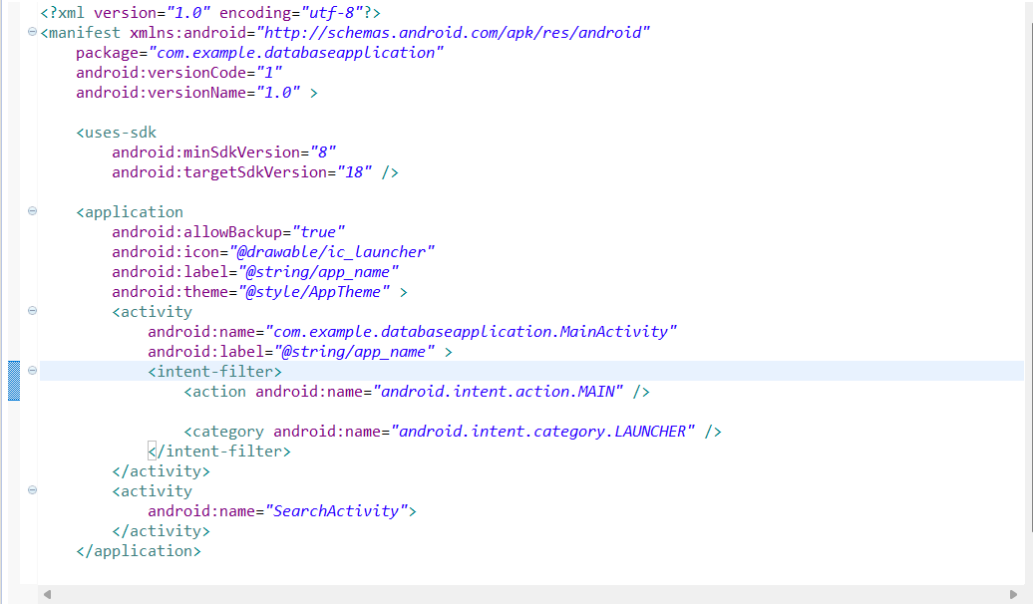

**Lab Program-8.** Create an .aidl service to do add, subtraction and multiplication and create another application with two buttons to read the inputs and three button add,subtract and multiply to call add,subtract and multiply operation on .aidl service.

**For 1st android project:**

calculator.aidl

package com.example.ca;

interface calculator

{

int add(int a,int b);

int sub(int a,int b);

int mul(int a,int b);

}

MyServices.java

**package** com.example.calculator;

**import** android.app.Service;

**import** android.content.Intent;

**import** android.os.IBinder;

**import** android.os.RemoteException;

**import** com.example.ca.calculator;

**public** **class** MyService **extends** Service{

@Override

**public** IBinder onBind(Intent arg0) {

// **TODO** Auto-generated method stub

**return** stub;

}

calculator.Stub stub=**new** calculator.Stub() {

@Override

**public** **int** sub(**int** a, **int** b) **throws** RemoteException {

// **TODO** Auto-generated method stub

**return** a-b;

}

@Override

**public** **int** mul(**int** a, **int** b) **throws** RemoteException {

// **TODO** Auto-generated method stub

**return** a*b;

}

@Override

**public** **int** add(**int** a, **int** b) **throws** RemoteException {

// **TODO** Auto-generated method stub

**return** a+b;

}

};

}

1st project manifest file(AndroidManifest.xml):

<service android:name=*"MyService"*>

<intent-filter >

<action android:name=*"com.sa.ca"*/>

</intent-filter>

</service>

(Note: A picture has been attached below which shows the place to include the above snippet)

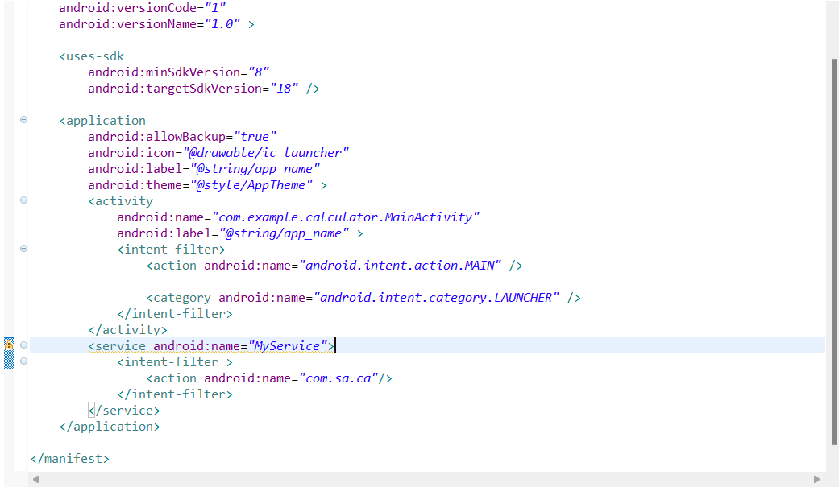

**For 2nd android project:**

calculator.aidl

package com.example.ca;

interface calculator

{

int add(int a,int b);

int sub(int a,int b);

int mul(int a,int b);

}

activity_main.xml

<LinearLayout xmlns:android=*"http://schemas.android.com/apk/res/android"*

xmlns:tools=*"http://schemas.android.com/tools"*

android:layout_width=*"match_parent"*

android:layout_height=*"match_parent"*

android:paddingBottom=*"@dimen/activity_vertical_margin"*

android:paddingLeft=*"@dimen/activity_horizontal_margin"*

android:paddingRight=*"@dimen/activity_horizontal_margin"*

android:paddingTop=*"@dimen/activity_vertical_margin"*

android:orientation=*"vertical"*

tools:context=*".MainActivity"* >

<TextView

android:layout_width=*"wrap_content"*

android:layout_height=*"wrap_content"*

android:layout_marginTop=*"10dp"*

android:text=*"Enter 1st number:"* />

<EditText

android:layout_width=*"fill_parent"*

android:layout_height=*"wrap_content"*

android:id=*"@+id/txt_fnum"*

android:layout_marginTop=*"10dp"*/>

<TextView

android:layout_width=*"wrap_content"*

android:layout_height=*"wrap_content"*

android:layout_marginTop=*"10dp"*

android:text=*"Enter 2nd number:"* />

<EditText

android:layout_width=*"fill_parent"*

android:layout_height=*"wrap_content"*

android:id=*"@+id/txt_snum"*

android:layout_marginTop=*"10dp"*/>

<LinearLayout

android:layout_width=*"wrap_content"*

android:layout_height=*"wrap_content"*

android:layout_marginTop=*"10dp"*

android:layout_gravity=*"center_horizontal"*>

<Button

android:layout_width=*"wrap_content"*

android:layout_height=*"wrap_content"*

android:text=*"Add"*

android:id=*"@+id/btn_add"*/>

<Button

android:layout_width=*"wrap_content"*

android:layout_height=*"wrap_content"*

android:text=*"Sub"*

android:id=*"@+id/btn_sub"*/>

<Button

android:layout_width=*"wrap_content"*

android:layout_height=*"wrap_content"*

android:text=*"Mul"*

android:id=*"@+id/btn_mul"*/>

</LinearLayout>

<TextView

android:layout_width=*"fill_parent"*

android:layout_height=*"wrap_content"*

android:layout_marginTop=*"10dp"*

android:id=*"@+id/txt_result"*/>

</LinearLayout>

MainActivity.java

**package** com.example.calculator1;

**import** com.example.ca.calculator;

**import** android.os.Bundle;

**import** android.os.IBinder;

**import** android.os.RemoteException;

**import** android.app.Activity;

**import** android.content.ComponentName;

**import** android.content.Intent;

**import** android.content.ServiceConnection;

**import** android.view.Menu;

**import** android.view.View;

**import** android.view.View.OnClickListener;

**import** android.widget.Button;

**import** android.widget.EditText;

**import** android.widget.TextView;

**import** android.widget.Toast;

**public** **class** MainActivity **extends** Activity **implements** OnClickListener,ServiceConnection{

Button add,sub,mul;

EditText num1,num2;

TextView display;

calculator ca;

@Override

**protected** **void** onCreate(Bundle savedInstanceState) {

**super**.onCreate(savedInstanceState);

setContentView(R.layout.*activity_main*);

display=(TextView)findViewById(R.id.*txt_result*);

num1=(EditText)findViewById(R.id.*txt_fnum*);

num2=(EditText)findViewById(R.id.*txt_snum*);

add=(Button)findViewById(R.id.*btn_add*);

add.setOnClickListener(**this**);

sub=(Button)findViewById(R.id.*btn_sub*);

sub.setOnClickListener(**this**);

mul=(Button)findViewById(R.id.*btn_mul*);

mul.setOnClickListener(**this**);

bindService(**new** Intent("com.sa.ca"), **this**, *BIND_AUTO_CREATE*);

}

@Override

**public** **boolean** onCreateOptionsMenu(Menu menu) {

// Inflate the menu; this adds items to the action bar if it is present.

getMenuInflater().inflate(R.menu.*main*, menu);

**return** **true**;

}

@Override

**public** **void** onClick(View v) {

// **TODO** Auto-generated method stub

**int** a=Integer.*parseInt*(num1.getText().toString());

**int** b=Integer.*parseInt*(num2.getText().toString());

**if**(v.equals(add)){

**int** res;

**try** {

res = ca.add(a, b);

display.setText(""+res);

} **catch** (RemoteException e) {

// **TODO** Auto-generated catch block

e.printStackTrace();

}

}

**if**(v.equals(sub)){

**int** res;

**try**{

res=ca.sub(a, b);

display.setText(""+res);

}

**catch**(RemoteException e){

e.printStackTrace();

}

}

**if**(v.equals(mul)){

**int** res;

**try** {

res=ca.mul(a, b);

display.setText(""+res);

} **catch** (RemoteException e) {

// **TODO** Auto-generated catch block

e.printStackTrace();

}

}

}

@Override

**public** **void** onServiceConnected(ComponentName arg0, IBinder arg1) {

// **TODO** Auto-generated method stub

Toast.*makeText*(getBaseContext(), "Service connected", Toast.*LENGTH_SHORT*).show();

ca=(calculator)calculator.Stub.*asInterface*(arg1);

}

@Override

**public** **void** onServiceDisconnected(ComponentName arg0) {

// **TODO** Auto-generated method stub

}

}

**Lab program-1b.** Develop a simple application with one EditText so that the user can write some text in it. Create a button called “Convert Text to Speech” that converts the user input text into voice.

activity_main.xml

<LinearLayout xmlns:android=*"http://schemas.android.com/apk/res/android"*

xmlns:tools=*"http://schemas.android.com/tools"*

android:layout_width=*"match_parent"*

android:layout_height=*"match_parent"*

android:paddingBottom=*"@dimen/activity_vertical_margin"*

android:paddingLeft=*"@dimen/activity_horizontal_margin"*

android:paddingRight=*"@dimen/activity_horizontal_margin"*

android:paddingTop=*"@dimen/activity_vertical_margin"*

android:orientation=*"vertical"*

tools:context=*".MainActivity"* >

<TextView

android:layout_width=*"wrap_content"*

android:layout_height=*"wrap_content"*

android:text=*"TEXT TO SPEECH APPLICATION"*

android:layout_gravity=*"center_horizontal"*

android:textSize=*"20sp"*

android:layout_marginTop=*"20dp"*/>

<EditText

android:layout_width=*"fill_parent"*

android:layout_height=*"wrap_content"*

android:id=*"@+id/txt_text"*

android:layout_marginTop=*"20dp"*/>

<Button

android:layout_width=*"wrap_content"*

android:layout_height=*"wrap_content"*

android:text=*"Convert Text To Speech"*

android:layout_gravity=*"center_horizontal"*

android:id=*"@+id/btn_convert"*

android:textSize=*"20sp"*

android:layout_marginTop=*"20dp"*/>

</LinearLayout>

MainActivity.java

**package** com.example.texttospeech;

**import** java.util.Locale;

**import** android.os.Bundle;

**import** android.app.Activity;

**import** android.speech.tts.TextToSpeech;

**import** android.view.Menu;

**import** android.view.View;

**import** android.view.View.OnClickListener;

**import** android.widget.Button;

**import** android.widget.EditText;

**import** android.widget.Toast;

**public** **class** MainActivity **extends** Activity **implements** OnClickListener{

Button convert;

EditText text;

TextToSpeech t1;

@Override

**protected** **void** onCreate(Bundle savedInstanceState) {

**super**.onCreate(savedInstanceState);

setContentView(R.layout.*activity_main*);

text=(EditText)findViewById(R.id.*txt_text*);

convert=(Button)findViewById(R.id.*btn_convert*);

convert.setOnClickListener(**this**);

t1=**new** TextToSpeech(getApplicationContext(), **new** TextToSpeech.OnInitListener() {

@Override

**public** **void** onInit(**int** status) {

// **TODO** Auto-generated method stub

**if**(status!=TextToSpeech.*ERROR*){

t1.setLanguage(Locale.*ENGLISH*);

}

}

});

}

@Override

**public** **boolean** onCreateOptionsMenu(Menu menu) {

// Inflate the menu; this adds items to the action bar if it is present.

getMenuInflater().inflate(R.menu.*main*, menu);

**return** **true**;

}

@Override

**public** **void** onClick(View v) {

// **TODO** Auto-generated method stub

String toSpeak=text.getText().toString();

**if**(v.equals(convert)){

Toast.*makeText*(getBaseContext(), toSpeak, Toast.*LENGTH_SHORT*).show();

t1.speak(toSpeak, TextToSpeech.*QUEUE_FLUSH*, **null**);

}

}

**public** **void** onPause(){

**if**(t1!=**null**){

t1.stop();

t1.shutdown();

}

**super**.onPause();

}

}

**Lab Program-7:** Write a program to create a service that will put a notification on the screen every 5 seconds.

activity_main.xml

<LinearLayout xmlns:android=*"http://schemas.android.com/apk/res/android"*

xmlns:tools=*"http://schemas.android.com/tools"*

android:layout_width=*"match_parent"*

android:layout_height=*"match_parent"*

android:paddingBottom=*"@dimen/activity_vertical_margin"*

android:paddingLeft=*"@dimen/activity_horizontal_margin"*

android:paddingRight=*"@dimen/activity_horizontal_margin"*

android:paddingTop=*"@dimen/activity_vertical_margin"*

android:orientation=*"vertical"*

android:layout_gravity=*"center_horizontal"*

android:gravity=*"center"*

tools:context=*".MainActivity"* >

<Button

android:layout_width=*"wrap_content"*

android:layout_height=*"wrap_content"*

android:text=*"Start Notification"*

android:id=*"@+id/btn_start"*/>

<Button

android:layout_width=*"wrap_content"*

android:layout_height=*"wrap_content"*

android:text=*"Stop Notification"*

android:id=*"@+id/btn_stop"*/>

</LinearLayout>

MainActivity.java

**package** com.example.notification;

**import** android.os.Bundle;

**import** android.app.Activity;

**import** android.content.Intent;

**import** android.view.Menu;

**import** android.view.View;

**import** android.view.View.OnClickListener;

**import** android.widget.Button;

**public** **class** MainActivity **extends** Activity **implements** OnClickListener{

Button start,stop;

@Override

**protected** **void** onCreate(Bundle savedInstanceState) {

**super**.onCreate(savedInstanceState);

setContentView(R.layout.*activity_main*);

start=(Button)findViewById(R.id.*btn_start*);

start.setOnClickListener(**this**);

stop=(Button)findViewById(R.id.*btn_stop*);

stop.setOnClickListener(**this**);

}

@Override

**public** **boolean** onCreateOptionsMenu(Menu menu) {

// Inflate the menu; this adds items to the action bar if it is present.

getMenuInflater().inflate(R.menu.*main*, menu);

**return** **true**;

}

@Override

**public** **void** onClick(View v) {

// **TODO** Auto-generated method stub

**if**(v.equals(start)){

Intent it=**new** Intent(**this**,ServiceNotification.**class**);

startService(it);

}

**else** **if**(v.equals(stop)){

Intent it=**new** Intent(**this**,ServiceNotification.**class**);

stopService(it);

}

}

}

ServiceNotification.java

**package** com.example.notification;

**import** android.annotation.SuppressLint;

**import** android.app.Notification;

**import** android.app.NotificationManager;

**import** android.app.PendingIntent;

**import** android.app.Service;

**import** android.content.Intent;

**import** android.os.Handler;

**import** android.os.IBinder;

**import** android.os.Message;

**import** android.support.v4.app.NotificationCompat;

**import** android.widget.Toast;

**public** **class** ServiceNotification **extends** Service{

**boolean** running=**false**;

MyThread thread;

@Override

**public** IBinder onBind(Intent arg0) {

// **TODO** Auto-generated method stub

**return** **null**;

}

@Override

**public** **void** onCreate() {

// **TODO** Auto-generated method stub

**super**.onCreate();

Toast.*makeText*(getBaseContext(), "Service Created", Toast.*LENGTH_SHORT*).show();

running=**true**;

thread=**new** MyThread();

thread.start();

}

@Override

**public** **int** onStartCommand(Intent intent, **int** flags, **int** startId) {

// **TODO** Auto-generated method stub

**super**.onStartCommand(intent, flags, startId);

Toast.*makeText*(getBaseContext(), "Service is Started", Toast.*LENGTH_SHORT*).show();

**if**(thread.isAlive()){

thread=**new** MyThread();

thread.start();

}

**return** Service.*START_NOT_STICKY*;

}

@Override

**public** **void** onDestroy() {

// **TODO** Auto-generated method stub

running=**false**;

Toast.*makeText*(getBaseContext(), "Service is Destroyed", Toast.*LENGTH_SHORT*).show();

**super**.onDestroy();

}

@SuppressLint("HandlerLeak")

Handler handle=**new** Handler(){

**public** **void** handleMessage(Message m){

NotificationManager manager=(NotificationManager)getSystemService(*NOTIFICATION_SERVICE*);

NotificationCompat.Builder builder=**new** NotificationCompat.Builder(getBaseContext());

builder.setContentTitle("From Service");

builder.setContentText("Hai" +m.what);

builder.setSmallIcon(R.drawable.*ic_launcher*);

builder.setContentIntent(PendingIntent.*getActivity*(getBaseContext(), 1, **new** Intent(getBaseContext(),MainActivity.**class**), 1));

Notification nof=builder.build();

manager.notify(100, nof);

}

};

**class** MyThread **extends** Thread{

@Override

**public** **void** run() {

// **TODO** Auto-generated method stub

**super**.run();

**int** i=0;

**while**(running){

**try**{

Thread.*sleep*(10000);

}**catch**(InterruptedException e){

e.printStackTrace();

}

handle.sendEmptyMessage(i++);

}

}

}

}

Manifest file (AndroidManifest.xml)

<service android:name=*"com.example.notification.ServiceNotification"*>

</service>

(Note: A picture has been attached below which shows the place to include the above snippet)

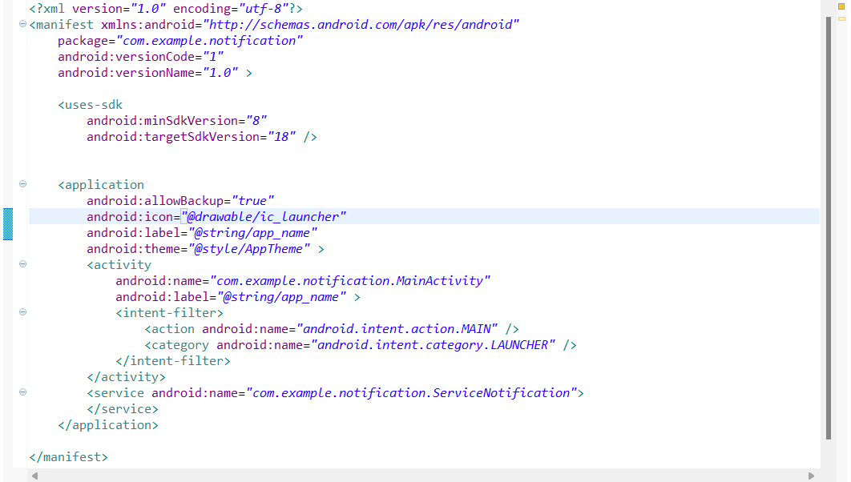

**Lab Program-6:**Create a program to receive the incoming SMS to the phone and put a notification on screen, on clicking the notification it must display sender number and message content on screen.

activity_main.xml

<LinearLayout xmlns:android=*"http://schemas.android.com/apk/res/android"*

xmlns:tools=*"http://schemas.android.com/tools"*

android:layout_width=*"match_parent"*

android:layout_height=*"match_parent"*

android:paddingBottom=*"@dimen/activity_vertical_margin"*

android:paddingLeft=*"@dimen/activity_horizontal_margin"*

android:paddingRight=*"@dimen/activity_horizontal_margin"*

android:paddingTop=*"@dimen/activity_vertical_margin"*

android:orientation=*"vertical"*

android:layout_gravity=*"center_vertical"*

android:gravity=*"center"*

tools:context=*".MainActivity"* >

<TextView

android:layout_width=*"wrap_content"*

android:layout_height=*"wrap_content"*

android:text=*"Sender Number"*

android:id=*"@+id/txt_number"*/>

<TextView

android:layout_width=*"wrap_content"*

android:layout_height=*"wrap_content"*

android:text=*"Message"*

android:layout_marginTop=*"20dp"*

android:id=*"@+id/txt_msg"*/>

</LinearLayout>

MainActivity.java

**package** com.example.broadcastreceiver;

**import** android.os.Bundle;

**import** android.app.Activity;

**import** android.view.Menu;

**import** android.widget.TextView;

**public** **class** MainActivity **extends** Activity {

TextView number,text;

@Override

**protected** **void** onCreate(Bundle savedInstanceState) {

**super**.onCreate(savedInstanceState);

setContentView(R.layout.*activity_main*);

number=(TextView)findViewById(R.id.*txt_number*);

text=(TextView)findViewById(R.id.*txt_msg*);

Bundle b=getIntent().getBundleExtra("data");

**if**(b!=**null**){

String numb=b.getString("num");

String msgr=b.getString("msg");

number.setText(numb);

text.setText(msgr);

}

}

@Override

**public** **boolean** onCreateOptionsMenu(Menu menu) {

// Inflate the menu; this adds items to the action bar if it is present.

getMenuInflater().inflate(R.menu.*main*, menu);

**return** **true**;

}

}

MySMSReceiver.java

**package** com.example.broadcastreceiver;

**import** android.content.BroadcastReceiver;

**import** android.content.Context;

**import** android.content.Intent;

**import** android.os.Bundle;

**import** android.telephony.SmsMessage;

**public** **class** MySMSReceiver **extends** BroadcastReceiver{

@Override

**public** **void** onReceive(Context arg0, Intent arg1) {

// **TODO** Auto-generated method stub

Object[] objmessages=(Object[])arg1.getExtras().get("pdus");

**for**(**int** i=0;i<objmessages.length;){

SmsMessage m=SmsMessage.*createFromPdu*((**byte**[])objmessages[i]);

Bundle b=**new** Bundle();

b.putString("num", m.getOriginatingAddress());

b.putString("msg", m.getMessageBody());

Intent it=**new** Intent(arg0,MainActivity.**class**);

it.putExtra("data", b);

it.setFlags(Intent.*FLAG_ACTIVITY_NEW_TASK*);

arg0.startActivity(it);

**break**;

}

}

}

Manifest file (AndroidManifest.xml)

<uses-permission

android:name=*"android.permission.RECEIVE_SMS"*/>

<receiver

android:name=*"com.example.broadcastreceiver.MySMSReceiver"*>

<intent-filter >

<action android:name=*"android.provider.Telephony.SMS_RECEIVED"*/>

</intent-filter>

</receiver>

(Note: A picture has been attached below which shows the place to include the above snippets)

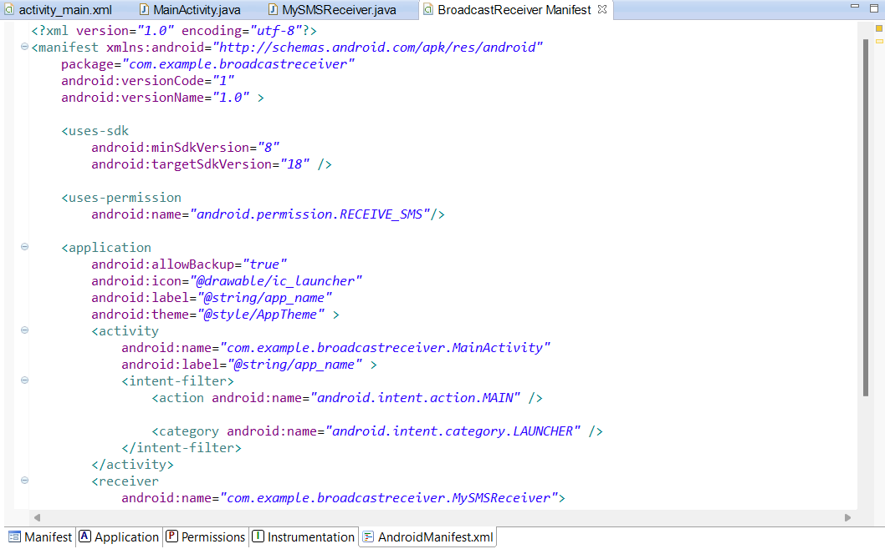

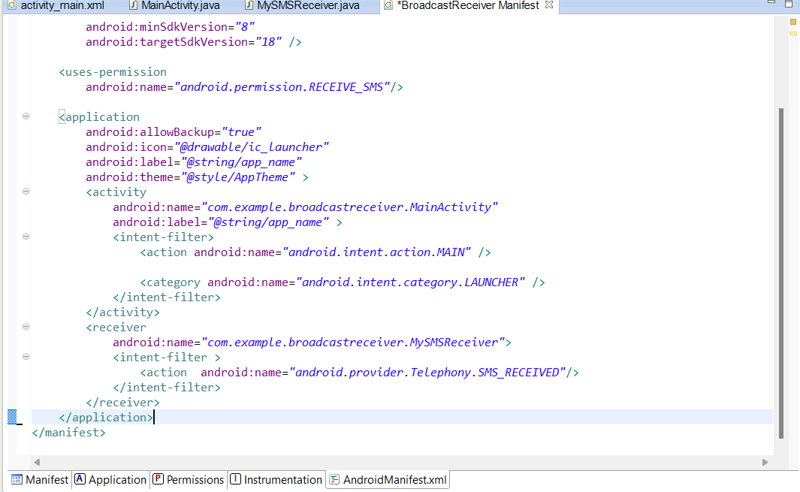

**Lab Program-3:** Write a program to create an activity with a text box and three buttons (save, open and create) open must allow to browse the text file from sdcard and must display the contents of the file on textbox, save button must save the contents of text box to file, create button must allow file user to create a new file and save the entered contents of the textbox.

activity_main.xml

<LinearLayout xmlns:android=*"http://schemas.android.com/apk/res/android"*

xmlns:tools=*"http://schemas.android.com/tools"*

android:layout_width=*"match_parent"*

android:layout_height=*"match_parent"*

android:paddingBottom=*"@dimen/activity_vertical_margin"*

android:paddingLeft=*"@dimen/activity_horizontal_margin"*

android:paddingRight=*"@dimen/activity_horizontal_margin"*

android:paddingTop=*"@dimen/activity_vertical_margin"*

android:orientation=*"vertical"*

android:gravity=*"center"*

tools:context=*".MainActivity"* >

<LinearLayout

android:layout_width=*"wrap_content"*

android:layout_height=*"wrap_content"*

android:layout_gravity=*"center_horizontal"*

android:orientation=*"horizontal"*>

<Button

android:layout_width=*"wrap_content"*

android:layout_height=*"wrap_content"*

android:text=*"Create new file"*

android:id=*"@+id/bth_create"*

android:layout_gravity=*"left"*/>

<Button

android:layout_width=*"wrap_content"*

android:layout_height=*"wrap_content"*

android:text=*"Open"*

android:layout_gravity=*"right"*

android:id=*"@+id/btn_open"*/>

</LinearLayout>

<TextView

android:layout_width=*"fill_parent"*

android:layout_height=*"wrap_content"*

android:gravity=*"center"*

android:text=*"File:"*

android:layout_marginTop=*"10dp"*

android:id=*"@+id/txt_file"*/>

<EditText

android:layout_width=*"match_parent"*

android:layout_height=*"200dp"*

android:id=*"@+id/txt_content"*/>

<Button

android:layout_width=*"wrap_content"*

android:layout_height=*"wrap_content"*

android:text=*"Save"*

android:layout_marginTop=*"10dp"*

android:layout_gravity=*"center"*

android:id=*"@+id/btn_save"*/>

</LinearLayout>

MainActivity.java

**package** com.example.fileoperations;

**import** java.io.BufferedReader;

**import** java.io.FileInputStream;

**import** java.io.FileNotFoundException;

**import** java.io.FileOutputStream;

**import** java.io.IOException;

**import** java.io.InputStreamReader;

**import** android.os.Bundle;

**import** android.app.Activity;

**import** android.view.Menu;

**import** android.view.View;

**import** android.view.View.OnClickListener;

**import** android.widget.Button;

**import** android.widget.EditText;

**import** android.widget.TextView;

**import** android.widget.Toast;

**public** **class** MainActivity **extends** Activity **implements** OnClickListener{

TextView lblfile;

EditText content;

Button create,save,open;

String FILE_NAME="example.txt";

@Override

**protected** **void** onCreate(Bundle savedInstanceState) {

**super**.onCreate(savedInstanceState);

setContentView(R.layout.*activity_main*);

lblfile=(TextView)findViewById(R.id.*txt_file*);

content=(EditText)findViewById(R.id.*txt_content*);

create=(Button)findViewById(R.id.*bth_create*);

create.setOnClickListener(**this**);

save=(Button)findViewById(R.id.*btn_save*);

save.setOnClickListener(**this**);

open=(Button)findViewById(R.id.*btn_open*);

open.setOnClickListener(**this**);

}

@Override

**public** **boolean** onCreateOptionsMenu(Menu menu) {

// Inflate the menu; this adds items to the action bar if it is present.

getMenuInflater().inflate(R.menu.*main*, menu);

**return** **true**;

}

@Override

**public** **void** onClick(View v) {

// **TODO** Auto-generated method stub

**if**(v.equals(open)){

FileInputStream fis=**null**;

**try**{

fis=openFileInput(FILE_NAME);

InputStreamReader isr=**new** InputStreamReader(fis);

BufferedReader bf=**new** BufferedReader(isr);

StringBuffer sb=**new** StringBuffer();

String text;

**while**((text=bf.readLine())!=**null**){

sb.append(text).append("/n");

}

content.setText(sb.toString());

fis.close();

bf.close();

}**catch**(FileNotFoundException e){

e.printStackTrace();

}**catch**(IOException e){

e.printStackTrace();

}

}

**else** **if** (v.equals(create)) {

String text=content.getText().toString();

FileOutputStream fos=**null**;

**try**{

fos=openFileOutput(FILE_NAME, *MODE_PRIVATE*);

fos.write(text.getBytes());

content.getText().clear();

Toast.*makeText*(getApplicationContext(), getFilesDir()+FILE_NAME, Toast.*LENGTH_SHORT*).show();

fos.close();

}**catch**(FileNotFoundException e){

e.printStackTrace();

}**catch** (IOException e) {

// **TODO**: handle exception

e.printStackTrace();

}

}

**else** **if**(v.equals(save)){

String text=content.getText().toString();

FileOutputStream fos=**null**;

**try**{

fos=openFileOutput(FILE_NAME, *MODE_PRIVATE*);

fos.write(text.getBytes());

content.getText().clear();

Toast.*makeText*(getApplicationContext(), getFilesDir()+FILE_NAME, Toast.*LENGTH_SHORT*).show();

fos.close();

}**catch**(FileNotFoundException e){

e.printStackTrace();

}**catch**(IOException e){

e.printStackTrace();

}

}

}

}

**Lab Program-10:** Create a file of JSON type with values for city_name, Latitude, Longitude, Temperature and Humidity. Develop an application to create an activity with button to parse the JSON file which when clicked should display the data in the textview.

activity_main.xml

<LinearLayout xmlns:android=*"http://schemas.android.com/apk/res/android"*

xmlns:tools=*"http://schemas.android.com/tools"*

android:layout_width=*"match_parent"*

android:layout_height=*"match_parent"*

android:paddingBottom=*"@dimen/activity_vertical_margin"*

android:paddingLeft=*"@dimen/activity_horizontal_margin"*

android:paddingRight=*"@dimen/activity_horizontal_margin"*

android:paddingTop=*"@dimen/activity_vertical_margin"*

android:orientation=*"vertical"*

android:gravity=*"center"*

tools:context=*".MainActivity"* >

<Button

android:layout_width=*"wrap_content"*

android:layout_height=*"wrap_content"*

android:id=*"@+id/btn_parse"*

android:text=*"Parse JSON File"*/>

<TextView

android:layout_width=*"match_parent"*

android:layout_height=*"wrap_content"*

android:text=*"Display Results"*

android:layout_marginTop=*"10dp"*

android:id=*"@+id/txt_display"*/>

</LinearLayout>

MainActivity.java

**package** com.example.jsonfile;

**import** java.io.IOException;

**import** java.io.InputStream;

**import** org.json.JSONArray;

**import** org.json.JSONException;

**import** org.json.JSONObject;

**import** android.os.Bundle;

**import** android.app.Activity;

**import** android.view.Menu;

**import** android.view.View;

**import** android.view.View.OnClickListener;

**import** android.widget.Button;

**import** android.widget.TextView;

**public** **class** MainActivity **extends** Activity **implements** OnClickListener{

TextView txt;

Button parse;

@Override

**protected** **void** onCreate(Bundle savedInstanceState) {

**super**.onCreate(savedInstanceState);

setContentView(R.layout.*activity_main*);

txt=(TextView)findViewById(R.id.*txt_display*);

parse=(Button)findViewById(R.id.*btn_parse*);

parse.setOnClickListener(**this**);

}

@Override

**public** **boolean** onCreateOptionsMenu(Menu menu) {

// Inflate the menu; this adds items to the action bar if it is present.

getMenuInflater().inflate(R.menu.*main*, menu);

**return** **true**;

}

@Override

**public** **void** onClick(View v) {

// **TODO** Auto-generated method stub

**if**(v.equals(parse)){

**try** {

InputStream is=getAssets().open("sample.json");

**int** size=is.available();

**byte**[] buffer=**new** **byte**[size];

is.read(buffer);

is.close();

String json=**new** String(buffer,"UTF_8");

JSONArray jsonArray=**new** JSONArray(json);

txt.setText("");

**for**(**int** i=0;i<jsonArray.length();i++){

JSONObject obj=jsonArray.getJSONObject(i);

txt.setText(txt.getText()+"\n City Name:"+obj.getString("City")+"\nLatitude:"+obj.getString("Latitude")

+"\nLongitude:"+obj.getString("Longitude")+"\nTemperature:"+obj.getString("Temperature")

+"\nHumidity:"+obj.getString("Humidity")+"\n");

}

} **catch** (IOException e) {

// **TODO** Auto-generated catch block

e.printStackTrace();

} **catch** (JSONException e) {

// **TODO** Auto-generated catch block

e.printStackTrace();

}

}

}

}

sample.json

[{

"City" : "Bengaluru",

"Latitude" : "12.9716",

"Longitude" : "77.5946",

"Temperature" : "27",

"Humidity" : "65"

},

{

"City" : "Delhi",

"Latitude" : "28.7041",

"Longitude" : "77.1025",

"Temperature" : "23",

"Humidity" : "62"

}]